**MIS 567**

**Module 5: Assignment 3 -- ARIS-II: Integrated Processes-Part 2**

By

**Sudharsan Elangovan**

Submission Date: 2/18/2024

Due Date: 2/18/2024

**Under the esteemed Guidance of**

**Hasan Kartal, Ph.D.**

**(Professor)**

**Exercise 9 – Process Overview with Even-Driven Process Chain (EPC)**

Description:

In Exercise 9, we created and verified an Event-driven Process Chain (EPC) for the Sales Processes within the United Motor Group (UMG) database using ARIS:

* We developed an EPC model in the ARIS tool to map out the sales processes, starting from customer contact to processing orders.
* We detailed the flow, starting with an event for existing customer contact and branching out based on whether a customer inquiry is defined or not. The process includes various functions like processing contacts, inquiries, and customer offers.
* We utilized ARIS's spell-check functionality to ensure accuracy and applied layout settings for visual clarity.
* The process flow incorporated various decision points, where different outcomes led to different functions or events, such as inquiry registration or rejection, and order processing.
* After defining the process flow and applying the layout settings, the model was saved in the ARIS database.

Purpose:

The exercise was aimed at understanding how to model a sales process flow accurately, considering various possible customer interactions and outcomes. It also demonstrated the importance of clarity and precision in process modeling to ensure that the process is easily understandable and correctly represents the business operations.

**Exercise 10 – Assignments (existing model)**

Description:

In Exercise 10 for ARIS, we focused on linking detailed models to a higher-level function within a Value-Added Chain Diagram (VACD). The steps we took were:

* We opened the Core Business Processes VACD: This is where we located our high-level overview of business processes.
* We right-clicked on the Sales function within the VACD and assigned the detailed Sales Processes EPC model to it. This creates a direct linkage within the database.
* We ensured that all changes were saved, integrating the detailed process flow into the higher-level business process model.

Purpose:

The purpose of this exercise was to document how the detailed Sales Processes EPC provides a more granular view of the aggregated Sales Function in the overarching Core Business Processes VACD. It showcases the capability of ARIS to connect different levels of process models, ensuring consistency and traceability throughout the process hierarchy.

**Exercise 11 – Occurrence Copy / Define Organizational Responsibility in EPC**

Description:

In Exercise 11, we worked on adding organizational elements to an Event-driven Process Chain (EPC) in ARIS, specifically focusing on the Sales Processes EPC

* We accessed the detailed EPC model that represents the sales process within the organization.
* We then integrated organizational units into the EPC by creating occurrence copies of "Sales Team Germany" and "Order Processing Germany," assigning them to their respective functions within the process. This was done to map out which teams are responsible for each part of the sales process.
* After integrating the organizational units, we saved the changes to maintain the integrity of the model and the database.

Purpose:

The purpose of this exercise was to ensure that the EPC reflects not just the process steps but also the organizational structure, showing clear lines of responsibility. Using occurrence copies avoids creating redundant objects in the database, streamlining the database structure, and making future analyses and evaluations more manageable.

**Exercise 12 – Detailed EPC / Assignments / Process Interfaces / Attribute Editing**

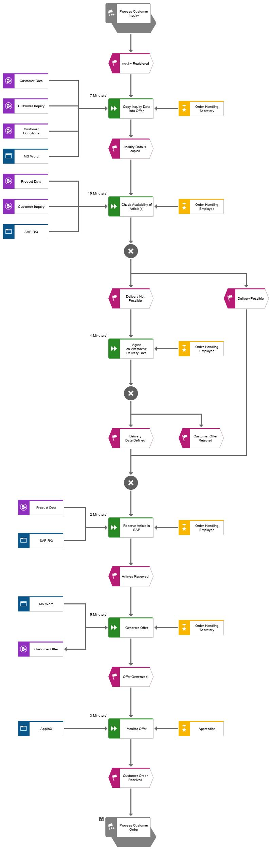

Description:

In Exercise 12, we were tasked with detailing an EPC by assigning more specific elements like organizational roles, IT systems, and data objects. We did this by:

* We assigned a detailed model to an aggregated function within the Sales Processes EPC.
* We incorporate process interfaces to connect different parts of the process.
* We add organizational elements to functions to specify responsibilities.
* We insert IT systems and data models that support the process, like the MS Word Application for generating offers.
* We used XOR operators to depict decision points within the process.
* We maintained attributes such as the average processing time for functions, which helps in performance analysis and process optimization.

Purpose:

The goal was to enrich the high-level process model with a detailed view that includes all supporting elements, thus providing a comprehensive understanding of the process, responsibilities, and systems involved. This detailed modeling in ARIS helps in streamlining process execution and identifying potential areas for efficiency gains.

**Exercise 13 – Detailed EPC / Assignments / Occurrence Copy**

Description:

In Exercise 13, we focused on the Process of Customer Inquiry within the Sales Processes EPC.

* We created a new detailed EPC model for the Process of Customer Inquiry and linked it to the corresponding function in the Sales Processes EPC using occurrence copies.
* We mapped out the preceding and succeeding events and functions around the customer inquiry process, ensuring the use of occurrence copies for consistency and to avoid redundancy.
* We added organizational roles such as the Sales Team and Order Processing, along with IT systems like SAP and MS Word, to illustrate the support systems for the process.
* We described the flow of actions and decisions, such as copying inquiry data, checking article availability, and calculating discounts, complete with decision points like XOR for branching paths based on conditions.

Purpose:

The objective was to model the inquiry phase in detail, incorporating all elements that interact with this phase, thus providing a full picture of the responsibilities, data flow, and IT systems involved. This detailed approach in ARIS helps in understanding each step's impact on the overall process and in identifying potential improvement areas.

**Exercise 14 – Modeling an Additional Detail EPC**

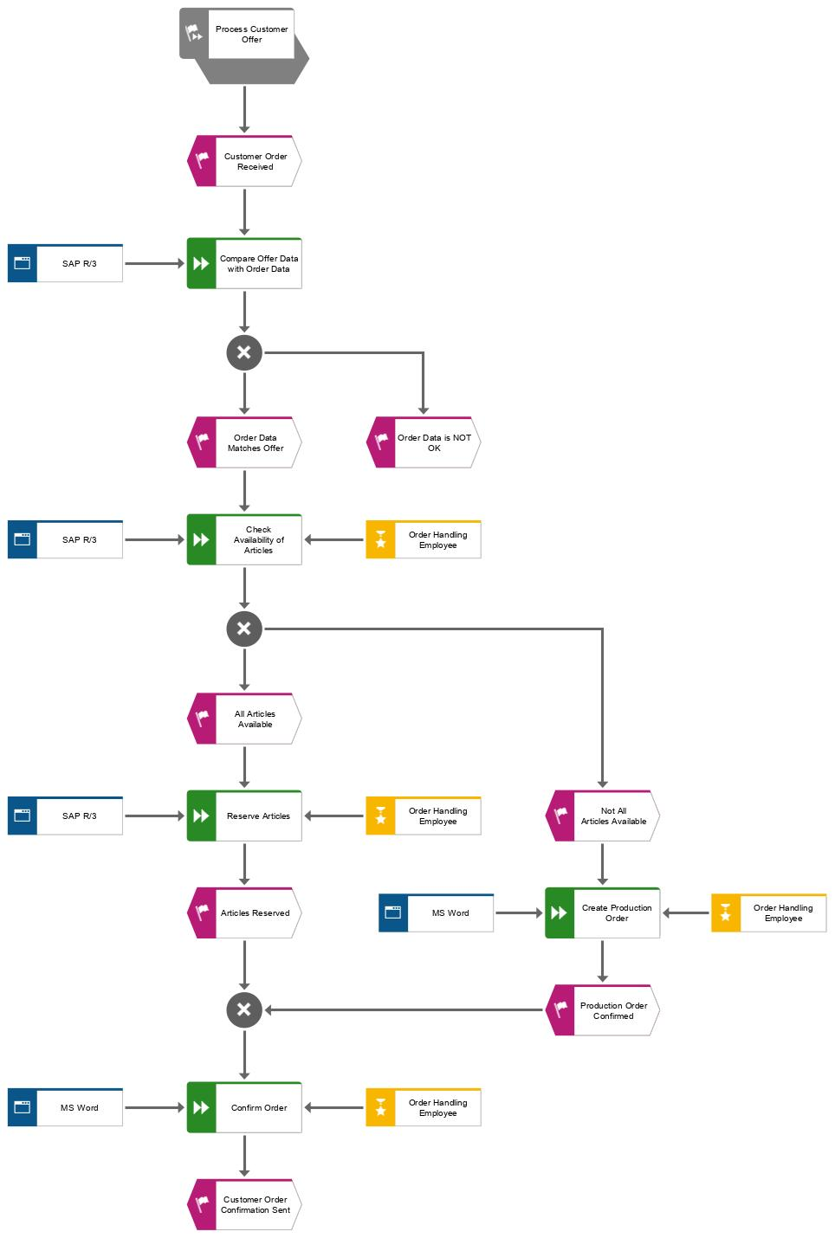

Description:

In Exercise 14, we continued to build upon the Sales Processes EPC by focusing on the Process Customer Order.

* We linked a detailed EPC model to the Customer Order function, providing a specific view of this segment of the sales process.
* We detailed the process steps, including comparing offer data with order data, checking the availability of articles, and reserving articles, using IT systems like SAP and MS Word to show data flow and process support.
* We ensured seamless navigation between the detailed EPC models and the higher-level Sales Processes EPC using process interfaces.
* We incorporated XOR operators to represent decision points and modeled parallel paths to represent different outcomes based on the availability of articles and confirmation of orders.

Purpose:

The exercise aimed to enhance our modeling skills, particularly in depicting a detailed view of process steps and their interfaces, while also considering organizational responsibilities and supporting application software within the process flow.